Yoga Retreat in Sardinia
with Jo Zukovich & Andrea Huber
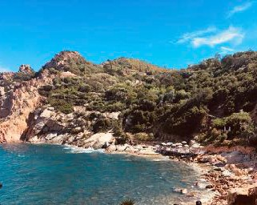
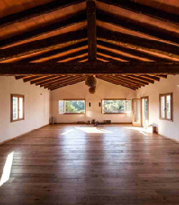

Find serenity & relaxation at this beautiful new retreat center located in the northern part of the Italian island Sardinia. You will practice Yoga, Pranayama and Meditation daily with enough time to explore the stunning land and the surrounding sea of Sardinia.
Jo Zukovich started her journey with Iyengar Yoga in 1979. Jo has travelled to India many times to study with B.K.S. Iyengar and his family. She has created several studios in San Diego and has been teaching internationally for over 10 years. Her classes are dynamic, energetic and fun. “Yoga connects us to nature and one another in a healthy way.”
Andrea Huber began her path of yoga in 1992 with Jo Zukovich. She has studied the art and philosophy of yoga with Jo and many other wonderful teachers of the Iyengar method. Her classes are spirited and vibrant. “The practice of yoga connects us to our hearts, helping us to live our lives more fully to bring forth our deepest gifts. “
When 21 – 28 Sep 2019
Ort: Balaiana Eco Retreat Center, Sardinia, Italy
Included in this retreat:
- 7 Nights in double-, triple-, or single rooms
- 2 vegetarian meals per day
- Yoga classes, mats, blocks, belts, blankets
- Towels and linens
A rental car is recommended, flight not included Price:
- 1490 Euro PP in Double Room
- 1740 Euro in Single Room (only 2 available)
- Triple Room upon request

Early Bird Pricing:
- 150€ off before November 30th 2018
- 90€ off before March 31st 2019

To book your spot:
- 300€ non-refundable deposit
- Final payment by April 30th 2019

Contact: info@omyoga.ch or jo@jozukovich.com

